
INTERNSHIP REPORT

A report submitted in partial fulfillment of the requirements for the Award of Degree of
BACHELOR OF ENGINEERING
in
COMPUTER ENGINEERING
by
Krishna Nagvekar ROLL NO: 22CO07
Under Supervision of Prayut Parsekar, CDO/Associate Director of IMMO Infotech, Merces Goa (Duration: 7th July 2025 to 5th September 2025)

DEPARTMENT OF COMPUTER ENGINEERING
AGNEL INSTITUTE OF TECHNOLOGY AND DESIGN
Assagao, Goa India Pin-403507
Goa University (2024-25)
DEPARTMENT OF COMPUTER ENGINEERING
AGNEL INSTITUTE OF TECHNOLOGY AND DESIGN
Assagao, Goa India Pin-403507

Approval Sheet

This is to certify that the “Internship report” submitted by Krishna A. Nagvekar, Roll No: 22CO07 is work done by him during the academic year 2025-26 and have been admitted to the candidacy of B.E (Computer Engineering) in July 2025 and have undertaken the internship at IMMO Information Technology Pvt. Ltd., Merces Goa which is approved for the degree of B.E. (Computer Engineering) under Goa University as it is found satisfactory.

Faculty Mentor:
Mr. Kedar Sawant, Asst Professor,
Computer Engineering Dept,
AITD Goa
Industry Mentor:
Prayut Parsekar,
CDO/ Associate Director,
IMMO Infotech, Merces, Goa

Mrs. Snehal Bhogan
Professor & Head Of Computer Engineering Dept,
AITD Goa

Date:
Place:

DECLARATION

I, Chaitanya alias Krishna A. Nagvekar, currently pursuing B.E in Computer, Fourth year from Agnel Institute of Technology and Design hereby declare that this report has been submitted by me on fulfillment of Eight weeks internship training at IMMO Information Technology Pvt. Ltd. , Merces Goa from 7th July 2025 to 5th September 2025

Place: Date:

ACKNOWLEDGEMENT

The internship opportunity I had at IMMO Information Technology Pvt. Ltd. was an invaluable experience that greatly contributed to my learning and professional development. I consider myself fortunate to have been part of such a dynamic and impactful project, VastuValue, where I contributed to creating a platform management system for property valuation. I am also deeply grateful for the chance to work alongside so many talented professionals who guided us throughout this journey.

I would like to express my heartfelt gratitude to Mr. Prayut Parsekar, my industry mentor, for his unwavering support, insightful advice, and valuable suggestions during the internship. His encouragement played a significant role in the success of this project, and I am sincerely appreciative of her contribution.

This internship marks a significant milestone in my career development, and I am thankful to IMMO Information Technology Pvt. Ltd. and all the staff for their cooperation, support, and warm hospitality. I am committed to applying the skills and knowledge I have gained in the best possible way and will continue to work on improving them to achieve my career goals. I look forward to continuing our collaboration in the future.

INDEX

Sr. No. | Content | Page No.
1 | Introduction
1 | 1.1 About IMMO Information Technology Pvt. Ltd. | 06
1 | 1.2 About VastuValue | 06
1 | 1.3 About Mentor | 07
1 | 1.4 Major Responsibilities As An Intern | 08
2 | Learning During the Internship | 09
3 | Position and Problem Statement | 10
4 | Weekly Overview of Internship Activities | 12
5 | Internship Overview
6 | Conclusion
7 | Certificate

INTRODUCTION
ABOUT IMMO Information Technology Pvt. Ltd.

Established in 2005, IMMO Infotech emerged with the aim to provide IT services to IAZI (www.iazi.ch), its parent company. It did not take us long to expand our expertise from real estate to specialised IT services, which we have designed to meet the specific needs of businesses operating in a competitive digital world.

We at IMMO Infotech firmly believe that one-size-fits-all approach doesn’t work in today’s dynamic digital scenario. Every business is different, so are the requirements. Hence we strive to package our software solutions in a way that increases operational efficiencies and takes businesses ahead on the path of growth.
Our vision is based on progress. We seek to achieve incremental growth as a leading software company and rise to the top of the success ladder. It is only when we get the right mix of strategy and creativity that we can concoct IT solutions that work best for businesses. We aim to keep ourselves up-to-date with the latest technologies so that we prove relevant to our vast and ever-growing skill set.

Products and Services

Real Estate Portfolio Management (REPM)
Provide full visibility and control over real estate direct investments using advanced digital technologies and integrated analysis tools.
Support dynamic evaluation from single properties to entire portfolios, enabling optimal strategy and improved performance.

Web Services
Provide a unified, secure platform for seamless internal and external business communication.
Eliminate the need for multiple fragmented applications by enabling smooth data transfer across OS, platforms, and languages.

- System Administration
Ensure reliable setup, maintenance, and regular updates of business IT systems.
Minimize downtime and disruptions, keeping infrastructure secure and high-performing.

ABOUT VastuValue
VastuValue introduces hedonic valuation, a data-driven property assessment method that delivers market-backed accuracy and real-time insights—helping buyers, banks, and real estate professionals make informed decisions.
Launching first in Mumbai, VastuValue brings Swiss-standard property valuation to India, with plans to expand to major cities like Pune, Bangalore, Delhi, Hyderabad, Chennai, and Kolkata for nationwide transparency in real estate.

ABOUT OUR INDUSTRIAL MENTOR
15+ year journey spanning across major MNCs and startups in diverse industries, from Hospitality to Education. Currently driving People Connect at The Grit City,Miss. Pranjali Dessai champions the transformative power of experiential learning and is dedicated to co-creating an education space that's both self-directed and collaborative.
MAJOR RESPONSIBILITIES AS AN INTERN
As an intern for the VastuValue, my responsibilities included:
Technology Understanding: Studied the existing product architecture built with Angular 19 frontend, .NET backend, and MS SQL database to understand services, workflows, and stored data.
Cloud Services Research: Learned AWS services including Lambda, S3, Cognito, Secrets Manager, DynamoDB, RDS, API Gateway, CloudFront, and SES to evaluate how the migration could be executed.
ER Diagram Design: Created and refined an Entity Relationship (ER) diagram for the migration plan, presented it to the COO, CTO, and CDO, and incorporated their feedback for improvement.
Pricing & Feasibility Analysis: Conducted in-depth research on AWS service pricing to estimate costs and ensure feasibility for large-scale deployment.
Prototype Development: Built a simple Angular 19 application integrated with AWS Lambda and DynamoDB to gain practical experience with serverless architecture.
Database Migration: Designed and created DynamoDB tables with appropriate schemas, indexes, and policies to replace the SQL Server structure.
IAM Role Setup: Configured IAM roles and policies required for secure Lambda and API operations.
API Development & Testing: Wrote and tested Lambda functions to handle API calls from the landing page to the valuation page, ensuring smooth data flow and system reliability.
Payment Integration: Implemented secure API calls to Razorpay’s backend and database while ensuring data confidentiality and compliance.
Performance Optimization: Applied techniques such as lazy loading to reduce response times and enhance user experience.
DevOps & CI/CD: Used Git and GitHub for version control (pull, push, merge), and implemented GitHub Actions for automated deployments to AWS.
Infrastructure as Code (IaC): Learned and applied Terraform for provisioning and managing cloud resources efficiently.
Collaboration & Presentation: Worked closely with mentors and senior executives, presenting progress, challenges, and solutions regularly.
LEARNING DURING THE INTERNSHIP

My internship at IMMO Infotech provided me with hands-on exposure to both enterprise application development and cloud migration strategy. The key learnings included:
- Full-Stack Understanding: Gained practical knowledge of Angular 19, .NET backend services, and SQL Server database design before transitioning to AWS.
- Cloud-Native Architecture: Developed a deep understanding of AWS services such as Lambda, DynamoDB, S3, API Gateway, Cognito, and CloudFront, and how they work together in a serverless environment.
- Database Migration Skills: Learned how to design and migrate relational database structures into DynamoDB while maintaining data consistency and efficiency.
- Cost Awareness: Understood the importance of cloud pricing and how cost estimations directly influence architectural decisions.
- Secure Development Practices: Learned to integrate sensitive third-party APIs like Razorpay securely, ensuring confidentiality of payment data.
- Performance Tuning: Experienced how techniques like lazy loading and optimized API design improve system scalability and user responsiveness.
- CI/CD Pipelines: Acquired skills in GitHub Actions for automated deployment, managing multiple environments (development, testing, production), and ensuring reliable release cycles.
- Infrastructure as Code: Built strong foundations in Terraform to provision cloud infrastructure in a repeatable, version-controlled manner.
- Agile Way of Working: Practiced iterative development, regular feedback sessions with senior leadership, and adapting solutions based on their inputs.
- Professional Communication: Improved presentation skills by pitching ER diagrams, architecture designs, and cost estimations to C-level executives.
- Collaboration & Teamwork: Learned how to work in sync with mentors, team members, and cross-functional roles while managing responsibilities effectively.

POSITION & PROBLEM STATEMENT
At IMMO Infotech, I served as a Cloud Intern, contributing to the migration of VastuValue from a traditional on-premise system to a modern, cloud-based application powered by AWS. My role combined technical research, solution design, hands-on development, and collaboration with senior leadership to ensure a scalable, secure, and cost-effective migration strategy.

I began by studying the existing system architecture, built with Angular 19 frontend, .NET backend, and MS SQL database, to understand how services were structured, how data was stored, and what predefined data types were used. Once I had a solid foundation of the current stack, I transitioned into learning AWS services such as Lambda, S3, Cognito, Secrets Manager, DynamoDB, RDS, API Gateway, CloudFront, and SES, which were identified as the core technologies for the migration.

As part of the internship, I helped design and present an Entity Relationship (ER) diagram that mapped out the proposed migration strategy. This involved multiple iterations, with feedback from the COO, CTO, and CDO, and an in-depth study of AWS pricing models to balance technical needs with cost efficiency.

To gain practical cloud development experience, I also built a prototype Angular 19 application integrated with AWS Lambda and DynamoDB, which allowed me to understand the fundamentals of serverless architecture and event-driven workflows. Following this, I worked on creating DynamoDB tables, setting up IAM roles and policies, and writing Lambda functions that replicated and enhanced the API calls from the original application, covering workflows from the landing page through to the valuation page.

My responsibilities also included secure integration with Razorpay APIs, ensuring the confidentiality of sensitive financial data and implementing performance optimization techniques such as lazy loading to reduce delays. I collaborated closely with mentors on establishing CI/CD pipelines using GitHub Actions, managed version control via Git and GitHub, and learned to implement Infrastructure as Code (IaC) with Terraform for repeatable and reliable cloud provisioning.

The Problem statement which was given to me is as follows :

The main objective assigned to me was to migrate the VastuValue application from a traditional architecture to a secure, scalable, and efficient cloud-native architecture using AWS services. The migration needed to ensure minimal disruption, secure handling of sensitive data, and improved application performance.

The solution was expected to address the following challenges:

- Legacy Stack Migration: Transition the existing Angular 19 and .NET system backed by MS SQL into a serverless, cloud-native model using services such as Lambda, DynamoDB, S3, API Gateway, CloudFront, Cognito, and SES.

- Data Architecture Redesign: Design and implement DynamoDB schemas that would replicate and optimize the relational data structures of SQL Server, ensuring consistency and scalability.

- Secure Payment Integration: Implement secure and efficient communication with Razorpay’s backend and databases while safeguarding confidential payment data.

- Performance & Reliability: Improve application responsiveness through optimization techniques like lazy loading and ensure fault tolerance in cloud services.

- Cloud Cost Management: Research and evaluate AWS pricing models to provide cost-effective architecture recommendations.

- Automation & CI/CD: Set up GitHub Actions for automated deployments and use Terraform to standardize infrastructure creation across development, testing, and production environments.

This problem statement allowed me to gain experience not only in cloud migration and serverless development, but also in cost analysis, security practices, and DevOps workflows, shaping my ability to think strategically about real-world software systems.
Weekly Overview Of Internship Activities

WEEK 1:
Day | Date | Task for the Day
Monday | 07-07-2025 | Studied key AWS services like S3, Lambda, API Gateway, and DynamoDB, and understood their roles in building a secure, scalable cloud app with India-specific deployment practices.
Tuesday | 08-07-2025 | Learned Angular basics: project setup with Angular CLI, components, modules, routing, and using ng serve to run the app. Also made a small mini project like a counter to practice components and event binding.
Wednesday | 09-07-2025 | Created a flowchart of the AWS architecture for the internship project, showing how different services like S3, API Gateway, Lambda, and DynamoDB work together in the web app.
Thursday | 10-07-2025 | Analyzed and selected AWS services for a cloud-based web app, including S3, CloudFront, ACM, API Gateway, Lambda, DynamoDB, and SES, with a focus on features and cost in USD and INR.
Friday | 11-07-2025 | Built a prototype web app with Angular frontend and .NET 8 Web API backend. It collects user data, sends it to the backend, and displays results. The app was tested locally and will be used for deployment testing on AWS.

WEEK 2 :
Day | Date | Task for the Day
Monday | 14-07-2025 | Learned to use Amazon S3 for creating a bucket, uploading and hosting static files, and setting public access permissions. Also watched a tutorial to understand its use better and explored the estimated costs needed for the project.
Tuesday | 15-07-2025 | Started a new prototype project for AWS cloud deployment using Angular for the frontend and .NET for the backend. Integrated Amazon DynamoDB to store and retrieve form data, preparing the system for a scalable and serverless architecture.
Wednesday | 16-07-2025 | Started making AWS Lambda functions to save form data into DynamoDB. This helps move the backend to a serverless system, which will be easier to manage and can grow with more users.
Thursday | 17-07-2025 | Successfully completed the prototype project. The Angular frontend is hosted on S3, and form data is sent via API Gateway to a Lambda function, which stores it in DynamoDB. This shows a complete serverless setup using core AWS services.
Friday | 18-07-2025 | Presented the project progress to company management, explaining the technologies used, how the system works, and the benefits of the serverless architecture implemented

WEEK 3:
Day | Date | Task for the Day
Monday | 21-07-2025 | Completed the Angular 19 frontend prototype of the project with all key UI components and user flow. After the presentation, we implemented a few suggested changes, including creating separate Lambda functions for GET and POST.
Tuesday | 22-07-2025 | Had a productive meeting with AWS experts to clarify our doubts about the Vastu Value cloud architecture. They provided clear guidance on deployment, security best practices, and how to scale using AWS services. We also completed the GitHub setup for version control and future CI/CD integration
Wednesday | 23-07-2025 | Set up Amazon SES (Simple Email Service) for the AWS-based prototype project. Learned to verify email addresses, configure permissions, and send emails using a Lambda function. Successfully integrated email functionality to support user communication within the serverless application.
Thursday | 24-07-2025 | Completed the integration of Amazon SES for email delivery and Amazon SQS for message queuing in the prototype project. Also set up a CI/CD pipeline using GitHub for automated deployment of Lambda functions and frontend code, making the system more efficient, scalable, and production-ready.
Friday | 25-07-2025 | Completed work on Amazon SQS and understood how it connects with Lambda for handling background tasks. Also explored the frontend code of the main company project to understand its flow and structure. This helped strengthen my understanding of the complete request-response cycle

WEEK 4:
Day | Date | Task for the Day
Monday | 28-07-2025 | Visualized the entire database structure using dbdiagram.io to understand the relationships between tables like ObjectData, Location, PaymentDetail, and others. This improved my understanding of how different parts of the system are connected.
Tuesday | 29-07-2025 | Analyzed frontend API integrations across multiple Angular components to understand how data like valuation results, transactions, and location-based insights are fetched and displayed using services. Explored component-service interactions in a real-world project.
Wednesday | 30-07-2025 | Worked on identifying and documenting all API calls used in the project, focusing on how different components interact with backend services. This improved understanding of data flow between frontend and backend and provided clarity on full-stack application integration.
Thursday | 31-07-2025 | Finalized the complete list of all API calls from the Angular frontend. Also began setting up the AWS Lambda function for backend processing and integration with API Gateway and DynamoDB.
Friday | 01-08-2025 | Worked on creating and deploying a .NET 8 AWS Lambda function named GoogleMapsLambda. This function uses the Google Maps API to get location information such as city and state based on latitude and longitude provided in the request.

WEEK 5:
Day | Date | Task for the Day
Monday | 04-08-2025 | Created and deployed a Lambda function on AWS to handle apartment form data submission. Integrated it with an SQS queue, defined the data model, tested the Lambda function manually using the AWS console, and confirmed that messages are correctly reaching the queue. UI integration and testing is pending.
Tuesday | 05-08-2025 | Connected the AWS Lambda function (ApartmentFormLambda) to API Gateway using an HTTP-based REST API. Configured CORS to allow access and deployed the endpoint. Successfully tested the API using Postman to ensure the Lambda function receives and processes the form data correctly.
Wednesday | 06-08-2025 | Reviewed the existing Lambda function that sends apartment form data to SQS. Planned the next step to create another Lambda function that will read messages from the queue and save them into DynamoDB for use in the valuation report.
Thursday | 07-08-2025 | Set up an AWS Lambda function to save apartment form data in DynamoDB and send it to an SQS queue. Connected it through API Gateway, enabled CORS, and tested the API successfully
Friday | 08-08-2025 | Reviewed the AppraisalController to understand its workflow for handling apartment price calculation requests, including input validation, mapping request data to internal models, calling the pricing service, and logging the results asynchronously.

WEEK 6:
Day | Date | Task for the Day
Monday | 11-08-2025 | Lambda Function for LocationDetails:  Developed and deployed the LocationDetails Lambda function to handle location-specific data processing. The function was integrated with the required API endpoints and tested for basic functionality
Tuesday | 12-08-2025 | Completed testing the AWS Lambda function interacting with DynamoDB. Fixed issues related to DynamoDB key mismatches and validated request formats. The Lambda now works as expected with DynamoDB.
Wednesday | 13-08-2025 | Created the SaveOrResendOtpLambda function, which generates and sends OTPs to users via email. It stores the hashed OTP in DynamoDB with an expiration time and limits repeated requests to prevent abuse, using AWS Lambda and Amazon SES.
Thursday | 14-08-2025 | Completed an AWS Lambda function to send OTPs to users via email for verification. It uses Amazon SES to send the email and DynamoDB to store the OTP with an expiry time. Successfully tested and integrated with the frontend for the Vastu Value project.
Friday | 15-08-2025 | —

WEEK 7:
Day | Date | Task for the Day
Monday | 18-08-2025 | Implemented an AWS Lambda function that fetches the required data from an external API and stores the final valuation results in the database. Started working on configuring and deploying a Lambda with Razorpay integration.
Tuesday | 19-08-2025 | Worked on fixing the errors displayed on the final result page and created a flow diagram illustrating the complete architecture, including AWS Lambda functions, DynamoDB, S3, Cognito, and API Gateway connections. Also explored and made progress on the payment integration part, which is still in progress.
Wednesday | 20-08-2025 | Refined the final evaluation report for accuracy and clarity, and deployed Lambda functions for Razorpay API integration to handle payment transactions seamlessly.
Thursday | 21-08-2025 | Continued development on the payment Lambda for Razorpay API integration, focusing on implementing and testing the functionality to handle payment transactions efficiently.
Friday | 22-08-2025 | Worked further on the payment Lambda, continuing implementation and testing to ensure reliable and efficient handling of Razorpay payment transactions.

WEEK 8:
Day | Date | Task for the Day
Monday | 26-08-2025 | Continued working on the payment Lambda, focusing on implementation and testing to ensure reliable and efficient handling of Razorpay payment transactions.
Tuesday | 27-08-2025
Wednesday | 28-08-2025 | —
Thursday | 29-08-2025 | —
Friday | 30-08-2025
WEEK 9:
Day | Date | Task for the Day
Monday | 01-09-2025
Tuesday | 02-09-2025
Wednesday | 03-09-2025
Thursday | 04-09-2025
Friday | 05-09-2025

Internship Overview

My work at IMMO Infotech focused on the migration of the VastuValue application to a cloud-native architecture, involving the design of an optimized ER diagram and implementation of AWS-based solutions for secure, scalable, and efficient property valuation.

ER Diagram:
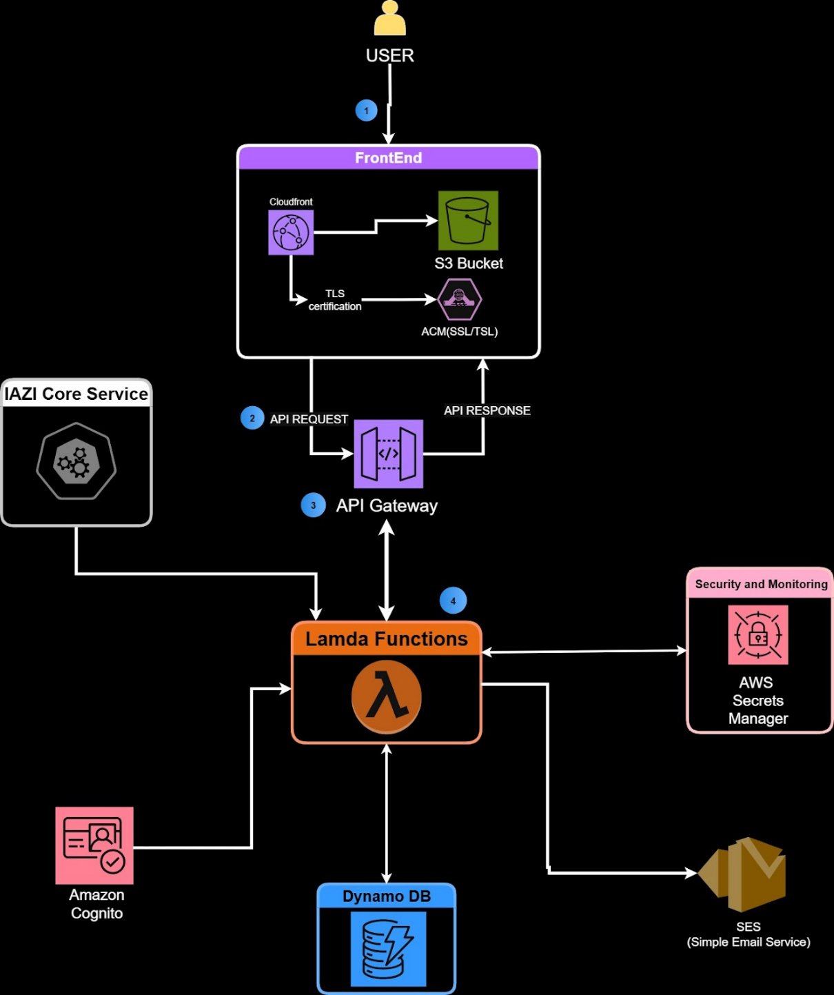
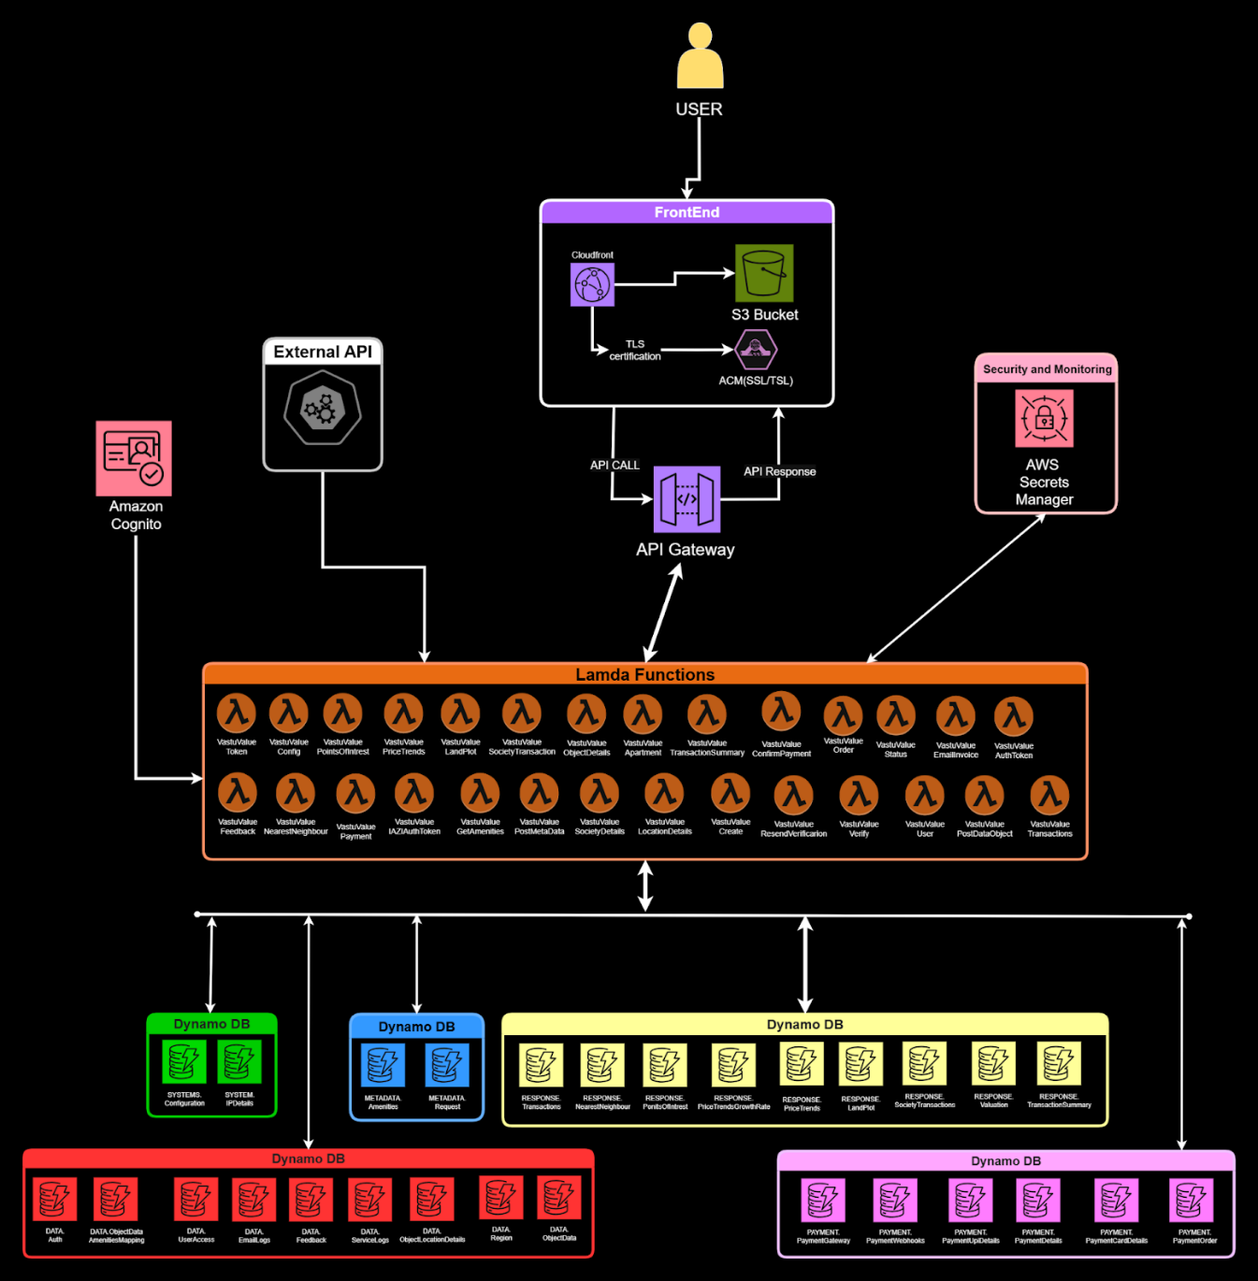
Landing Page:
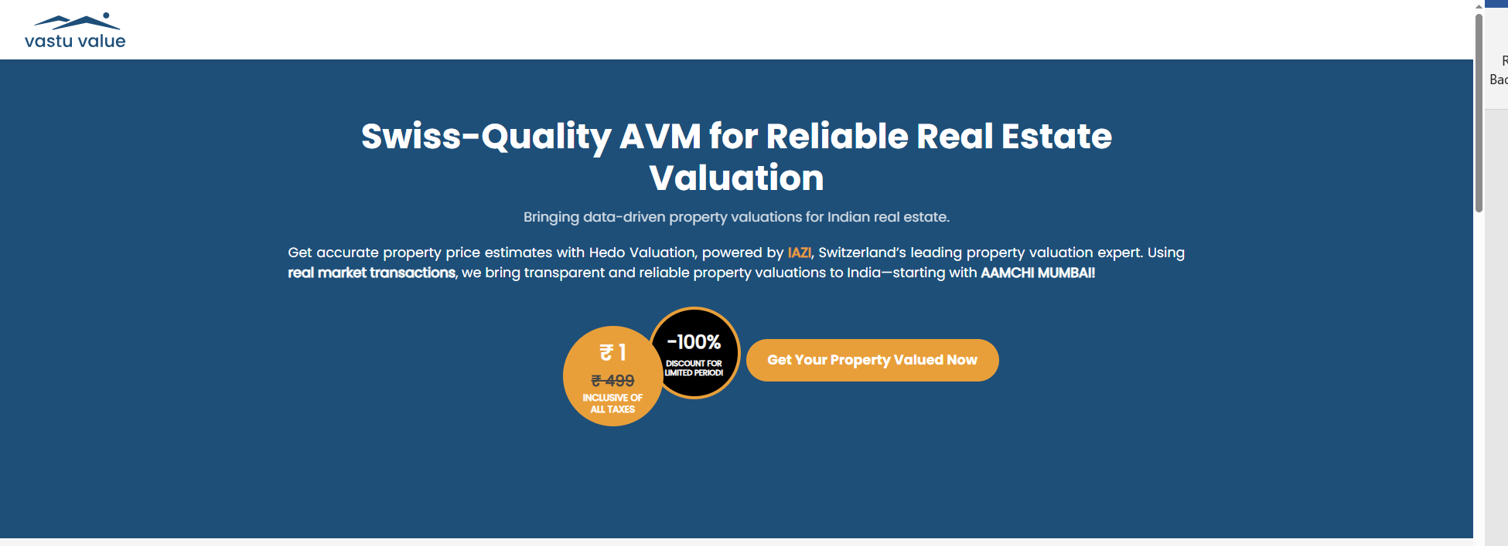

Location Page:
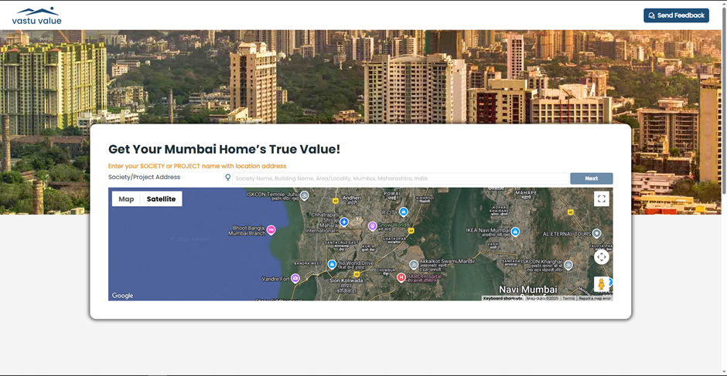
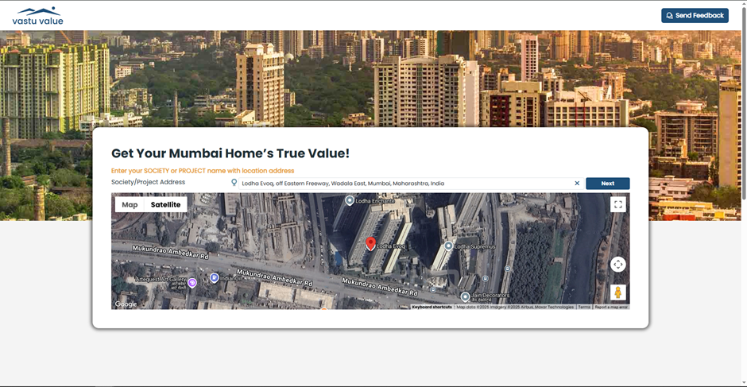
This page is for selecting the location of your property.

Location Details Page: This page is for the user to fill in the details for the selected location
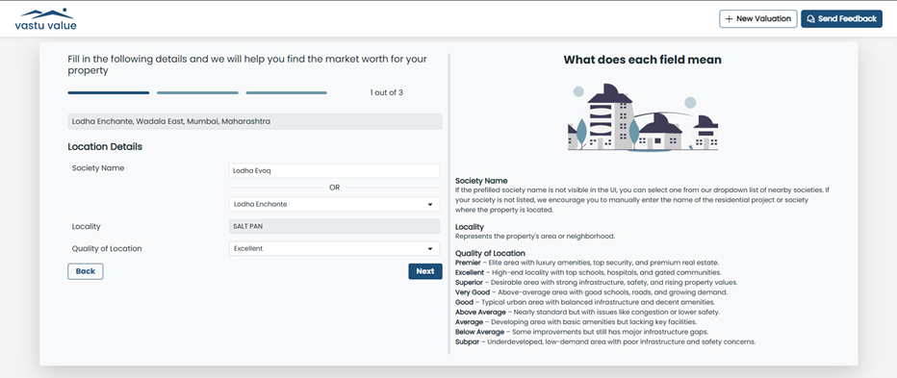

Apartment Details Page: This page is for the user to fill in the details for the Apartment
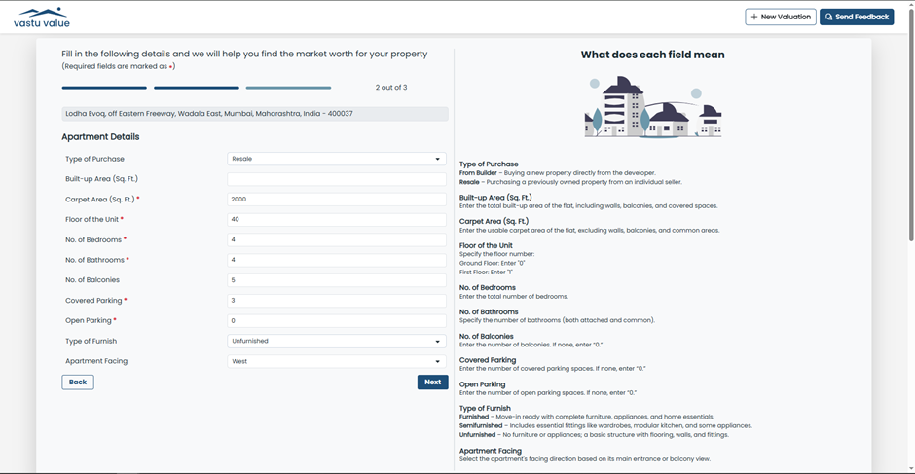

Building Details Page: This page is for the user to fill in the details for the Building
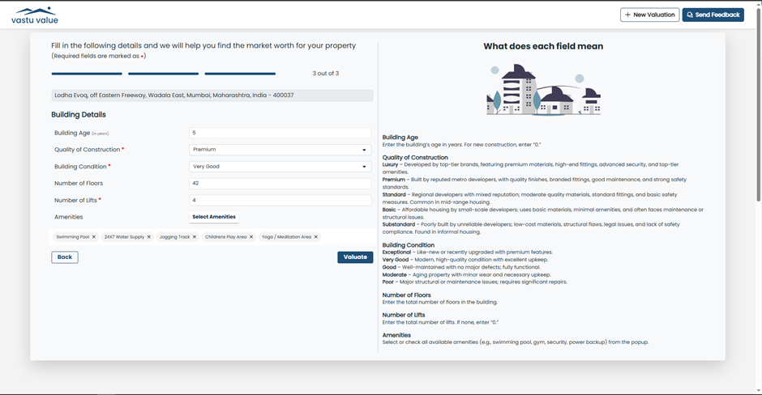
User Verification Page: This page verifies whether the user exists in the database or not.
If user does not exist, user is created, verified via OTP through Email & details are stored in the database and directed to the payment page.
If User exists, they are directed to the payment page skipping OTP verification step
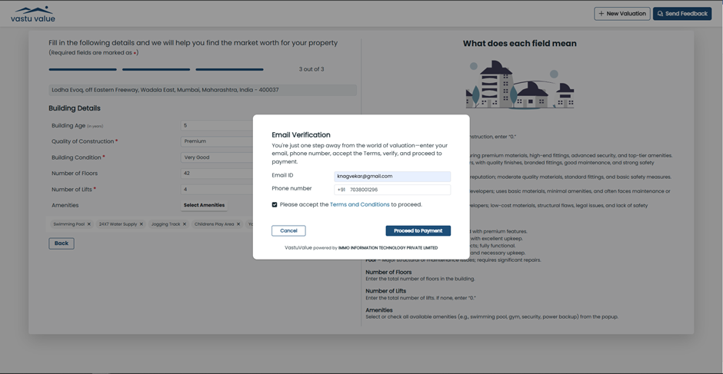
Razorpay: This page is for the user choose their mode of payment
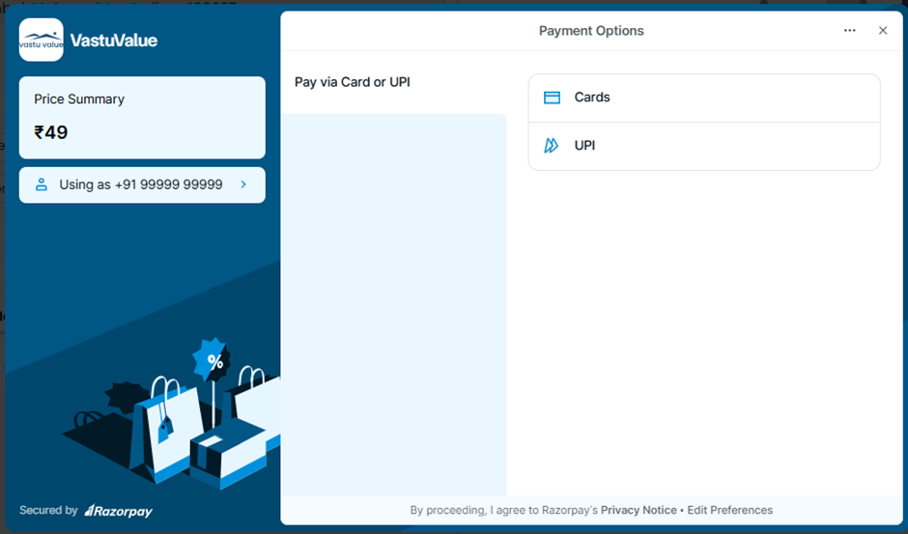

Final Report Page:
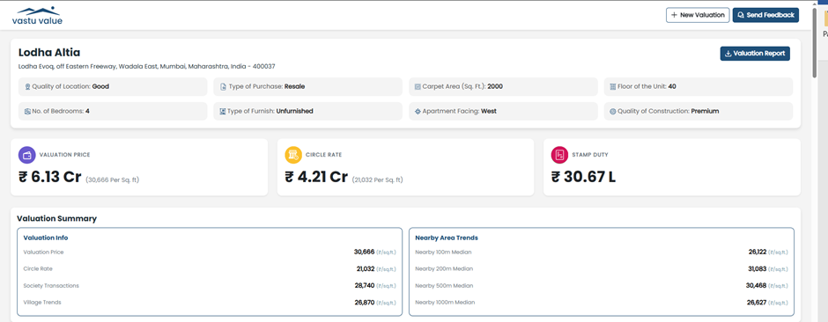
Ujhhj
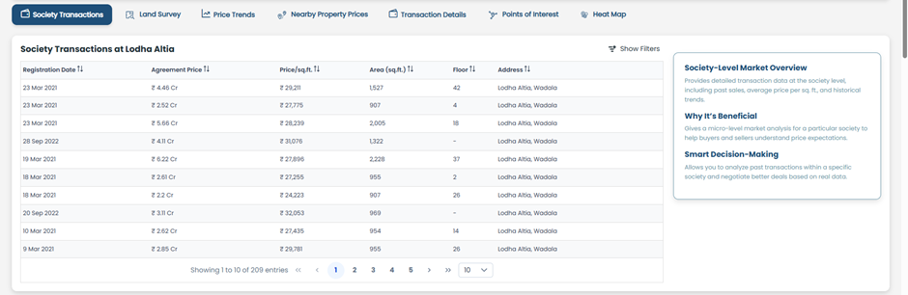
Dfsfd
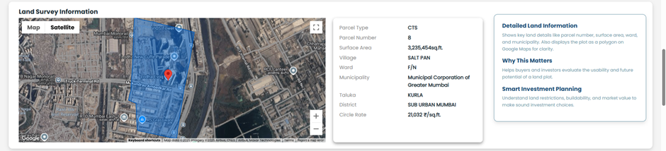
Dfsfdcv
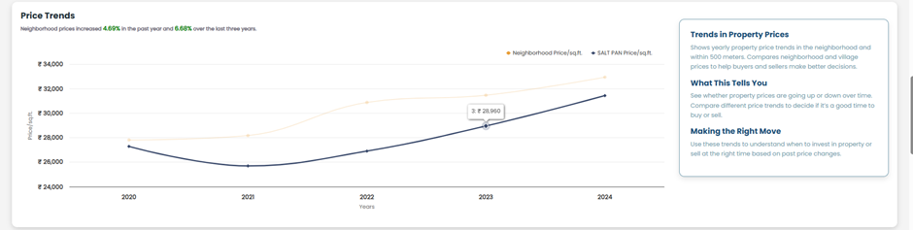
Fgdgd
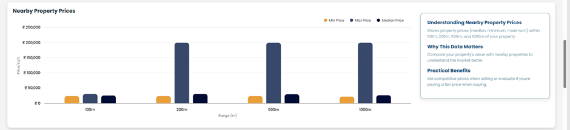
Hjghj
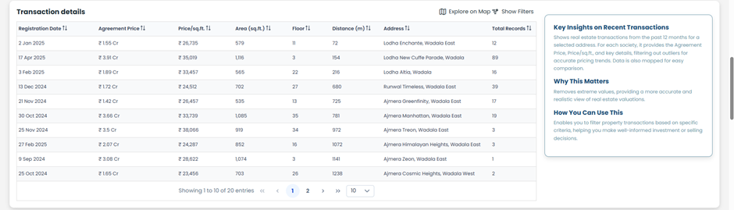
Dfsvc
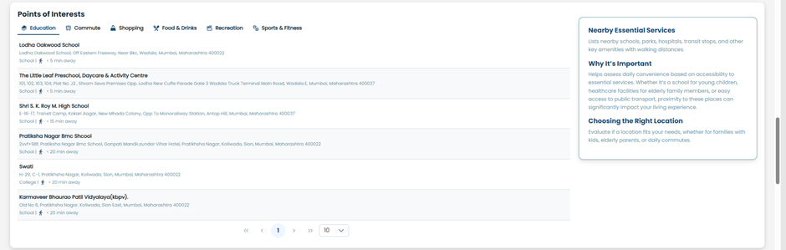
Fdgdfb
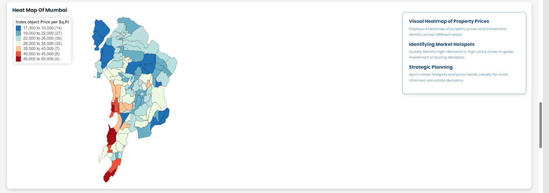
CONCLUSION
The internship at IMMO Infotech has been an immensely rewarding experience, providing me with both technical knowledge and professional growth. I had the opportunity to work on the migration of the VastuValue application—a project that combined modern cloud technologies with real-world business requirements. Through this, I gained hands-on exposure to Angular, .NET, and SQL Server, while also learning how to redesign and implement the system using AWS services such as Lambda, DynamoDB, API Gateway, S3, Cognito, CloudFront, and SES.

This internship also allowed me to deepen my understanding of cloud architecture, DevOps practices, and Infrastructure as Code. By working with Git, GitHub Actions, and Terraform, I not only built technical skills but also learned how to work in collaborative, production-grade environments. Presenting ER diagrams, cloud cost estimations, and solution designs to senior executives further strengthened my ability to communicate ideas effectively.

Overall, this internship has enhanced my ability to approach complex problems strategically, design secure and scalable solutions, and adapt to the fast-changing technology landscape. I am grateful for the guidance of my mentors and the opportunity to contribute to a project with significant potential for impact in India’s real estate sector. The knowledge and skills I have gained will serve as a strong foundation for my future career, reinforcing my commitment to building meaningful and innovative solutions through technology.

CERTIFICATE

